GitHub Actions
https://www.youtube.com/watch?v=R8_veQiYBjI

Platform to automate developer workflows
CI/CD is one of the many worfklows

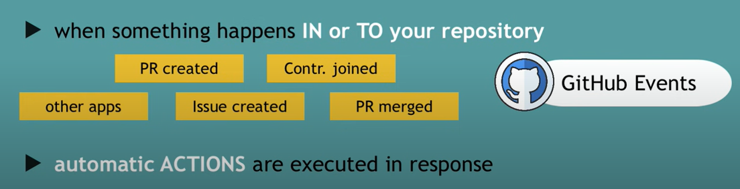

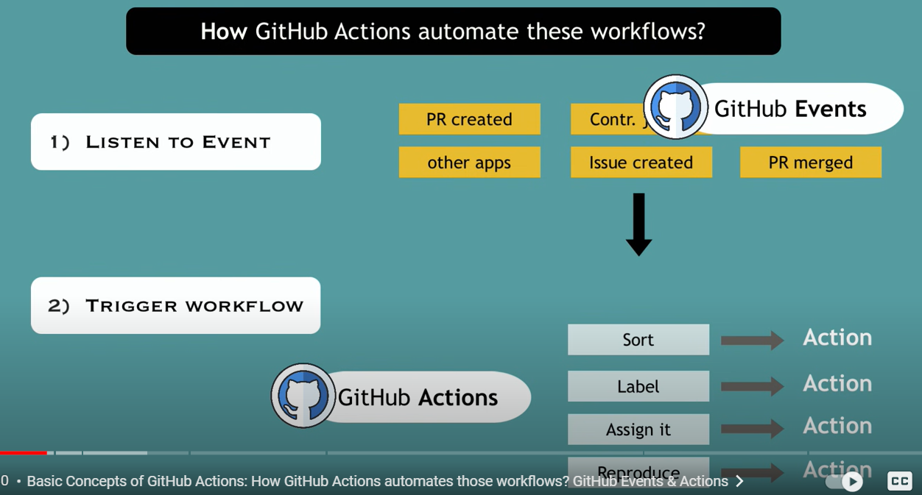

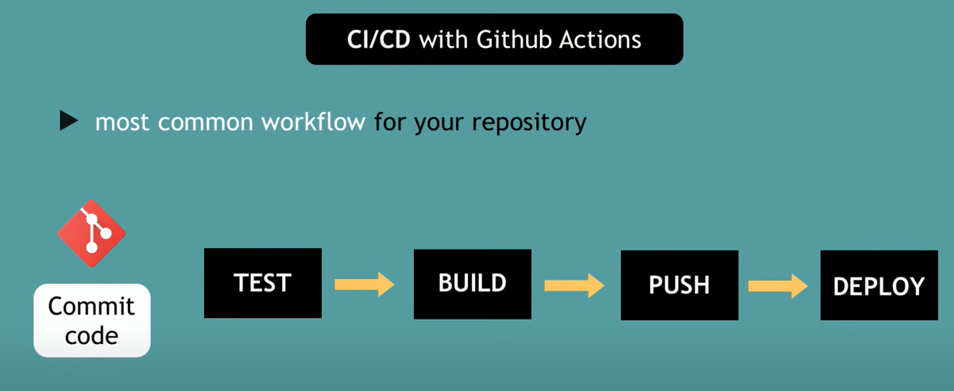

Advantages

- Use same tool (which stores code) instead of third party integration
- Setup the pipeline is easy
- Tool for developers

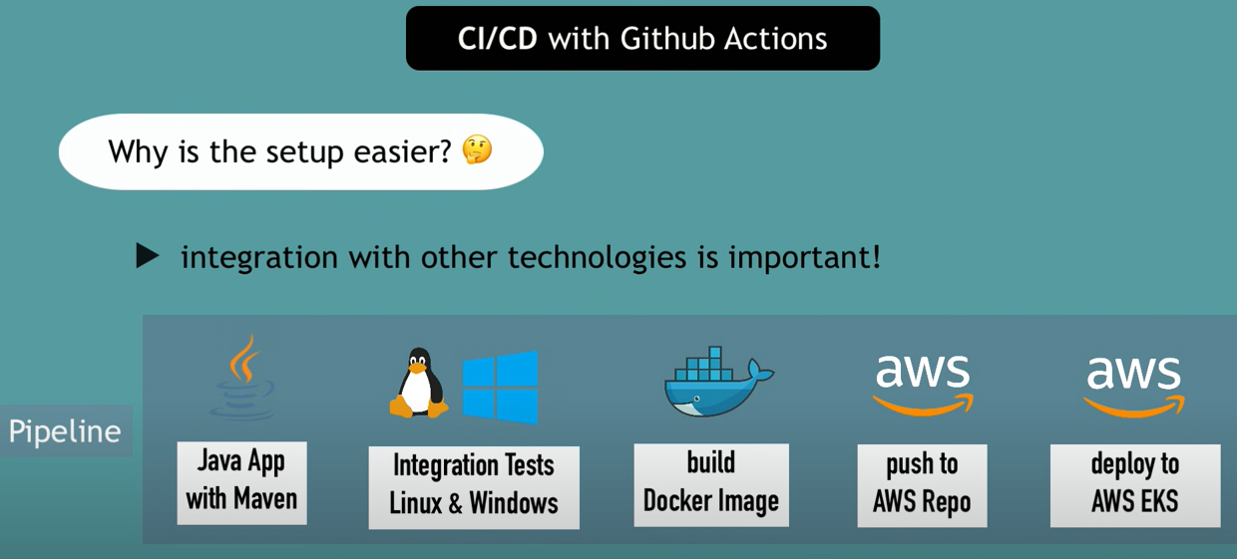
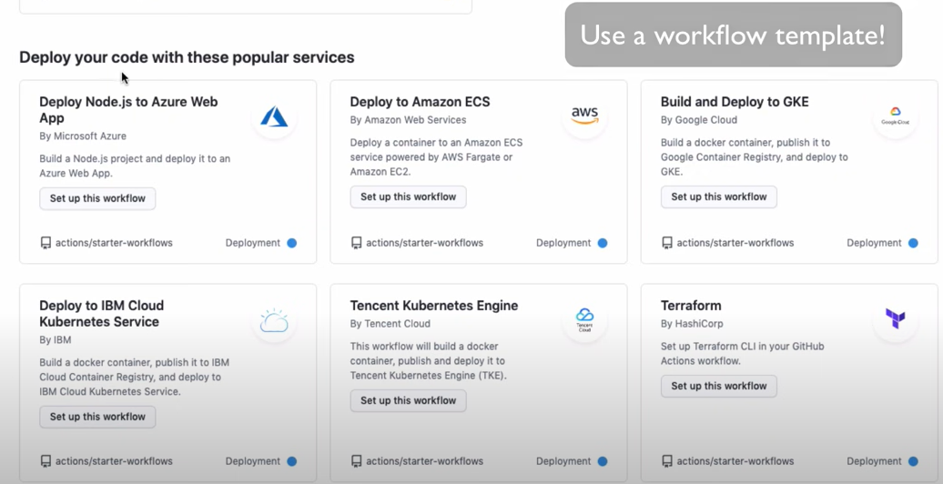

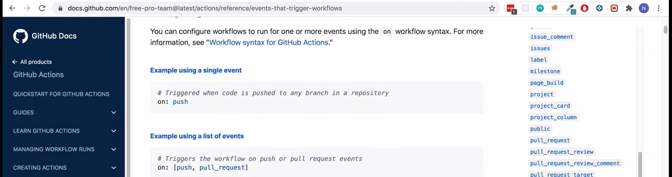

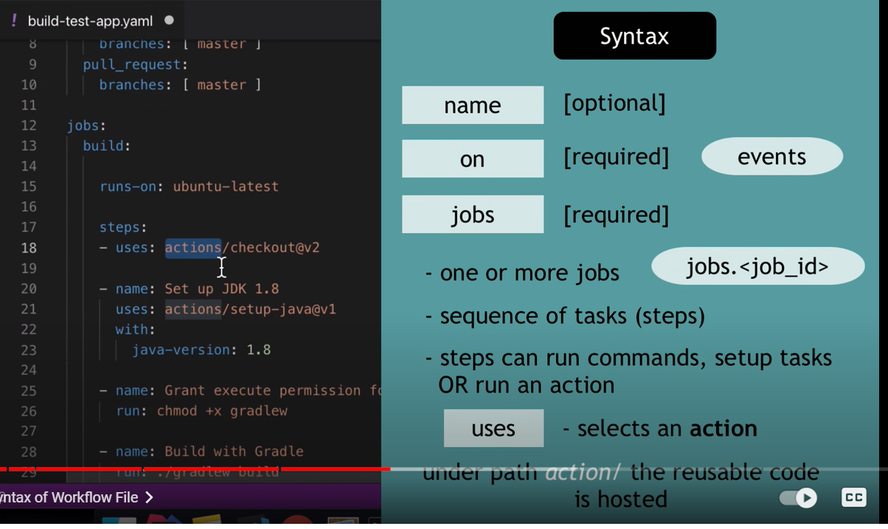

Name - name of the job
On - how the workflow need to be triggered
Jobs - jobs need to be run

checkout@v2 setup-java@v1 are predefined actions in Github (they have there own repository and yaml files)

no need to install or configure anything here
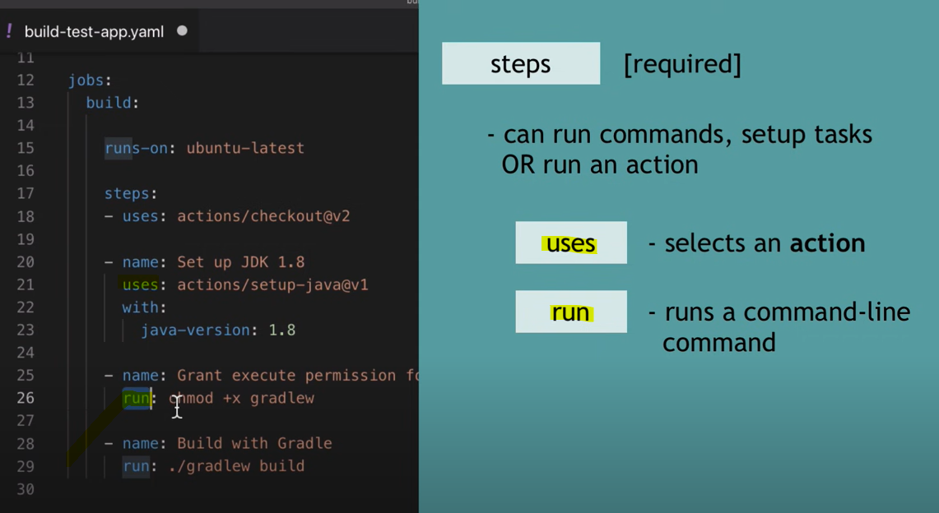

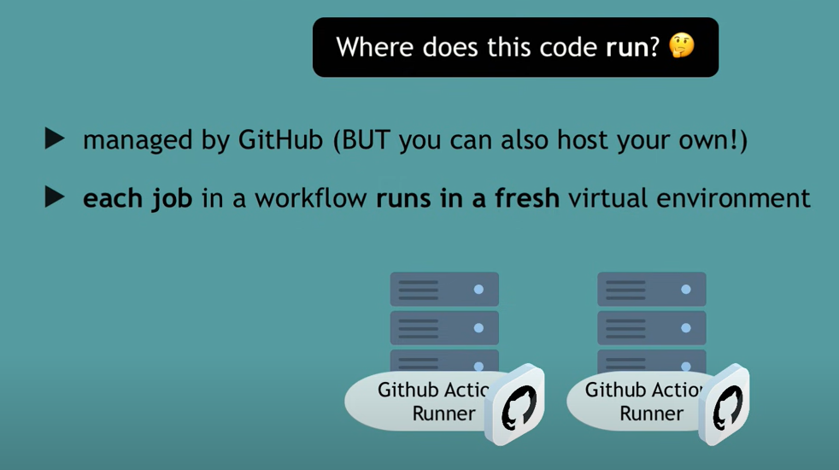

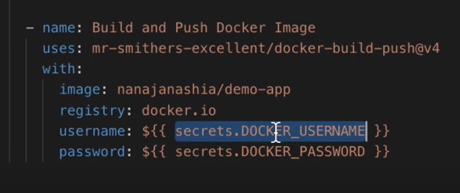

https://www.udemy.com/course/github-actions-the-complete-guide

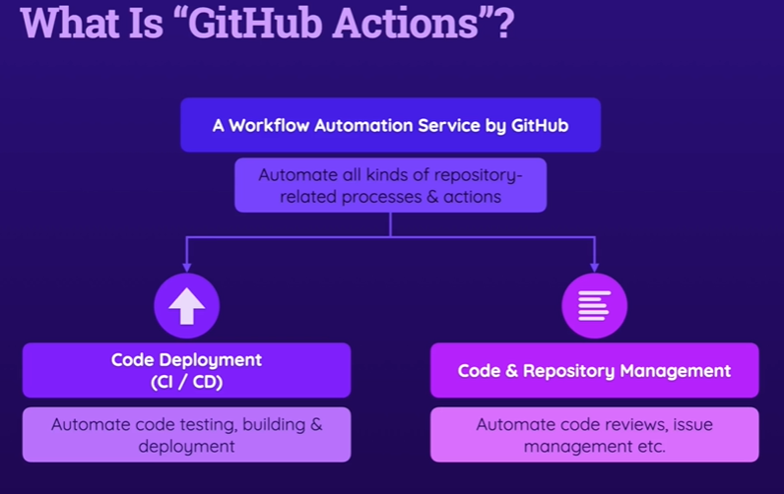

https://academind.com/community/

----------------------------------------------------------------------------------------------------------------------------
Git Hub Action Basic Building Blocks & Components

Key Components – Workflows , Jobs & Steps

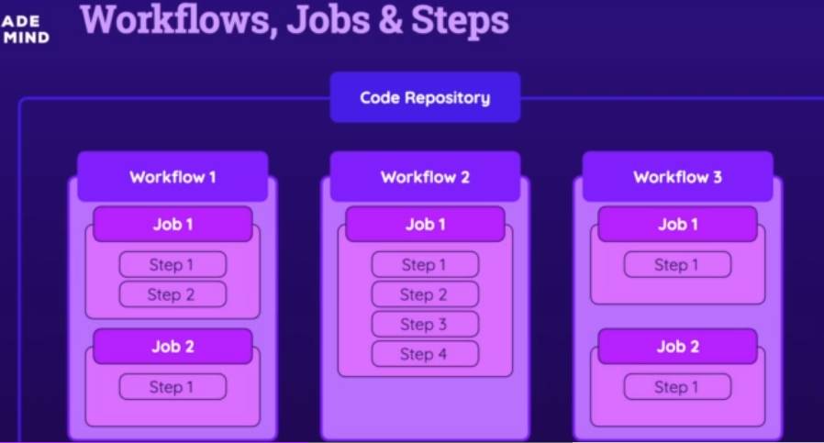

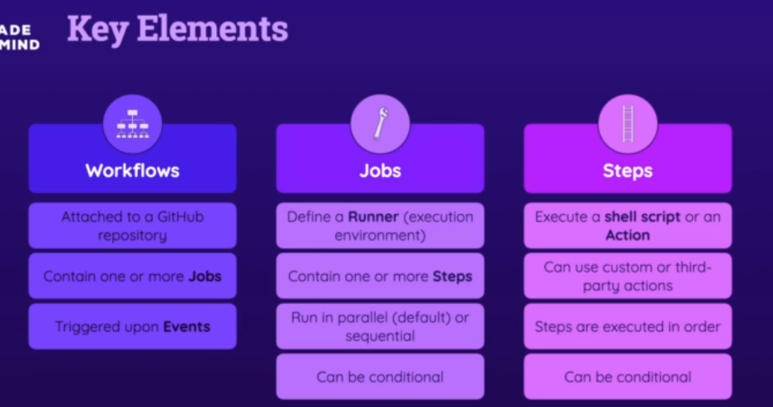

Name
on : event
jobs:
runs-on: runner , execution environment
steps :
- name:
- run : shell script or an action

If you need to run multiple shell commands (or multi-line commands, e.g., for readability), you can easily do so by adding the pipe symbol (|) as a value after the run: key.

